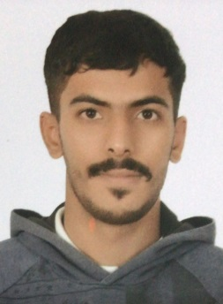

**Ahmed Mohamed Ali Mohamed**



Villa 339, Building 1804, Road 2152, block 1018, AL LAWZI

**Mobile :** +973 38458567



Ahmedalqdehe141@gmail.com

**Date of Birth :** July 15, 1998

**Marital Status :** Married

**Nationality :** Bahraini

**Personal Profile**

A competent and organized individual who is able to work as part of a team and manage several priorities at any one time. Has a positive attitude, strong work ethic, and a keen desire to learn and grow within a firm. Possesses superb communications skills, and always treats people with respect and according to their individual needs. A dedicated professional, fully understands the importance of the Logistics department to any organization, and therefore aims to make any office as effective and efficient as possible. Fully understands the pressures of achieving targets and accurately assessing job applicants according to their ability.

**Work Experience**

**Warehouse Supervisor**

Imerys Alzayani Fused Minerals W.L.L. **MAR 17**

- Achieve high levels of customer satisfaction through excellence in receiving, identifying, dispatching and assuring quality of goods.

- Measure and report the effectiveness of warehousing activities and employees performance.

- Organize and maintain inventory and storage area.

- Ensure shipments’ and inventory transactions’ accuracy.

- Communicate job expectations and coach employees.

- Determine staffing levels and assign workload.

**Forklift Operator**

Imerys Alzayani Fused Minerals W.L.L. **DEC 16 – FEB 2017**

**-** Loading and unloading goods from vehicles (container trucks).

**-** Moving goods packed on pallets or in crates around the storage facility.

**-** Stacking goods in the correct storage bays, following inventory control instructions.

**-** Checking loads are secure.

Stacking empty pallets.

**-** Performing daily equipment checks such as recharging the truck’s battery and lubricating equipment.

**-** Examining products to verify conformance to quality standards.

**Security Guard**

Imerys Alzayani Fused Minerals W.L.L. **JUL 16 – NOV 16**

- Secures premises and personnel by patrolling property; monitoring surveillance equipment; inspecting buildings, equipment, and access points; permitting entry.

- Obtains help by sounding alarms.

- Prevents losses and damage by reporting irregularities; informing violators of policy and procedures; restraining trespassers.

- Controls traffic by directing drivers.

**Education & Qualifications**

**First Aid / CPR Certificate 2018**

**Forklift License 2016**

**Secondary School Certificate (industrial) 2013 – 2015**

Al Jabriya Secondary Technical Boys School – Ministry of Education, Bahrain

**Skills & Work Strengths**

- Fluent speaking and writing in Arabic & English.

- Establishing excellent relationships with customers.

- Excellent & Professional working knowledge of Microsoft Word, Excel, and PowerPoint.

- Ability to solve theoretical and practical problems systematically.

- Excellent leadership attitude and good teamwork*.*

- Problems solving, time and self-management.

- Working under pressure.